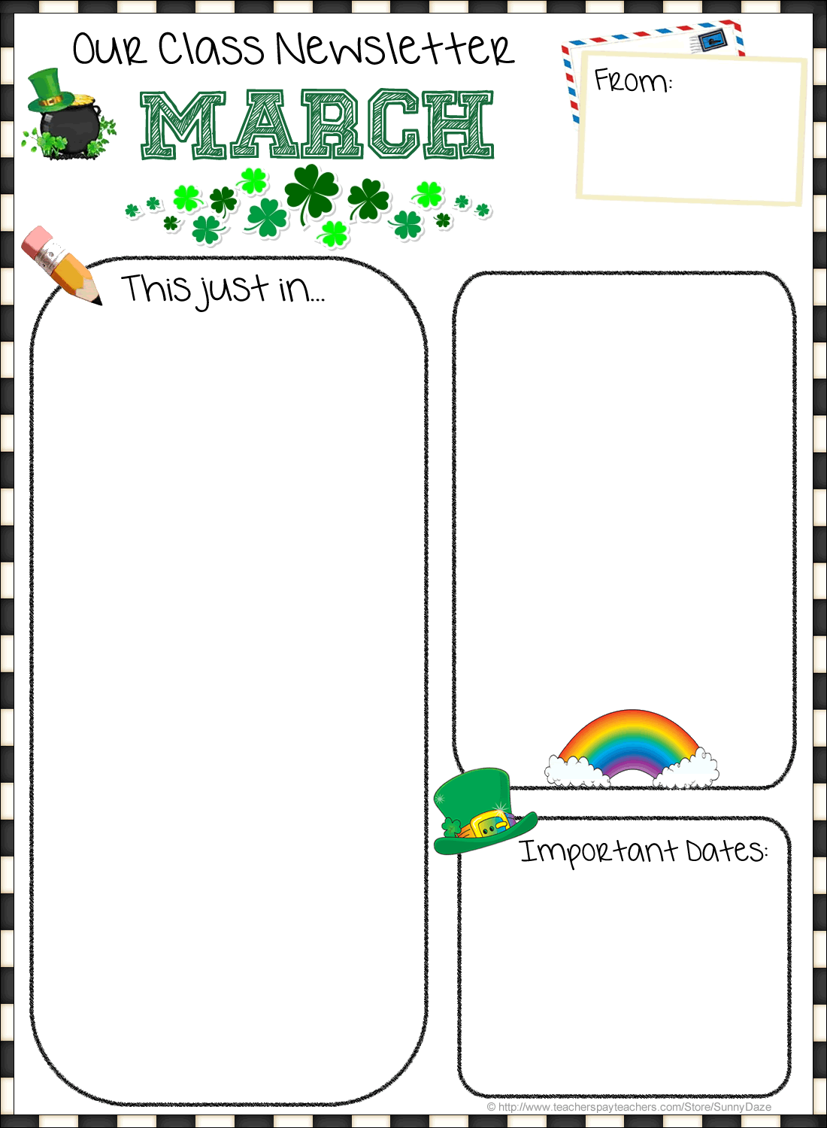

**March’s**

**Specials Schedule:**

*The weeks in this month start with:*

March 5th: D Day

March 12th: A Day

March 19th: B Day

March 26th: C Day



**Home-School Communication:**

My website is back up and working! Please continue to encourage your child to read each night and fill in the nightly reading log. The students have been doing a great job returning their homework each day. Thanks for all you do to support your child’s learning. ☺

**Spirit Week (March 26th-29th) Schedule:**

Monday – Read with a buddy

Tuesday – Create something together

Wednesday – Free Choice

Thursday – School wide sing along

Trait of the Month for March:

***Be Responsible***

☺

Our class is split up for specials each day.

Use the table above to determine your child’s schedule.

Your child knows what color group they are in.

**Contacting**

**Mrs. Popielarz…**

2018

• **Email:** apopielarz@rhnet.org

• **Phone:** (585) 359-5430

• **Classroom** **Website:** www.rhnet.org/webpages/apopielarz

Fyle Elementary   
Mrs. Popielarz  
Third Grade



**ELA/Writing:**

This month we will continue to work on reading short passages and writing well organized responses to questions about the text using RADD. We are learning the difference between an answer and a supporting detail as we dive deeper to explain our thinking. We are also learning strategies for answering multiple choice questions about a text. In writing we are also learning how to write opinion pieces using more than one reason to persuade others that our opinion is correct. In reading groups we have been learning how to make inferences about a character using what the character does and says and our own background knowledge.

**Math:**

We will continue our fractions unit throughout the rest of the month. The focus points in this unit include:

* Understand that a fraction is an equal part of a whole.
* Understand that a fraction can be represented on a number line.
* Understand that some fractions are equivalent (equal) and be able to generate simple equivalent fractions.
* Know that whole numbers can be expressed as fractions (6 = 6 / 1).
* Will be able to partition shapes into parts with equal areas and label each part as a unit fraction.

**Science/Social Studies:**

We will continue to learn about Kenya, studying the same aspects of the country and the cultures found there. Students are making a comparison chart of China and the US. They will do the same as we study Kenya. Coming soon…SCIENCE! We will be studying interdependent relationships in ecosystems, including a focus on fossils as well as ant colonies (I know, interesting connection!)

**Important Dates:**

March 23rd **Talent show** 7pm-9pm

March 26th– 29th **Spirit Buddy Week**

(See our schedule under Home- School Communications on the first page)

March 30th **Good Friday** – No School

April 2nd –April 6th **Spring Break**-No School